Section 1: Case Summary

Scenario Title: | Asthma in Pregnancy
Keywords: | Asthma, pregnancy
Brief Description of Case: | A third trimester patient presents with a severe asthma exacerbation that deteriorates and requires BiPAP/ICU admission. The learner will need to identify severe asthma and manage accordingly accounting for differences in physiology during pregnancy.

Goals and Objectives
Educational Goal: | Work through the steps of managing a progressively severe asthma exacerbation in pregnancy
Objectives:  (Medical and CRM) | Medical:  - Recognize physiologic changes in pregnancy (e.g. normal PCO2 in pregnancy is 32mmHg)  - Initiate FHR monitoring during medical emergency in pregnancy  - Demonstrate stepwise pharmacological/respiratory support and treatments for severe asthma exacerbation in pregnancy  CRM:  - Early recognition of critically ill pregnant patient and the involvement of appropriate consultants  - Communicate effectively with team to manage patient with multiple priorities
EPAs Assessed: | C7 - Managing urgent and emergent presentations for pregnant and post-partum patients

Learners, Setting and Personnel
Target Learners: | ☒ Junior Learners |  | ☒ Senior Learners |  |  | ☐ Staff
 | ☐ Physicians | ☐ Nurses |  | ☐ RTs | ☐ Inter-professional
 | ☐ Other Learners:
Location: | ☒ Sim Lab |  | ☐ In Situ |  |  | ☐ Other:
Recommended Number of Facilitators: | Instructors: 2
 | Sim Actors: 0
 | Sim Techs: 1

Scenario Development
Date of Development: | April 26, 2023
Scenario Developer(s): | Helene Morakis
Affiliations/Institutions(s): | PGY4 resident at University of British Columbia Emergency Medicine
Contact E-mail: | hmorakis@qmed.ca
Last Revision Date:
Revised By:
Version Number:

Section 2A: Initial Patient Information

- Patient Chart
Patient Name: Janet |  |  |  | Age: 30 | Gender: F | Weight: 80kg
Presenting complaint: Shortness of breath
Temp: 36.9 | HR: 95 | BP: 99/59 |  | RR: 32 | O₂Sat: 85% | FiO₂: Room Air
Cap glucose: 7 mmol/L |  |  |  | GCS: 15 (E4 V5 M6 )
Triage note:
30 y/o F G1P0 at 35 weeks GA presents with shortness of breath increasing over the last few days. She has a cough and ran out of salbutamol overnight which is why she came to the ED this morning.
Allergies: None
Past Medical History:  G1P0  Asthma: triggered by viral infections, irritants. Intubated x1 for exacerbation at age 11, ED visit and oral steroid 1 year ago. Previously followed by Family Physician but currently lost to follow up due to moving cities. |  |  | Current Medications:  Salbutamol 100mcg inhaled as needed (dispensed 2 in the last month)  Budesonide (ran out last month, has not renewed)  Prenatal vitamins

Section 2B: Extra Patient Information

A. Further History
Include any relevant history not included in triage note above. What information will only be given to learners if they ask? Who will provide this information (mannequin’s voice, sim actors, SP, etc.)?

Patient has a history of 7 days of dry cough and had 3 days of fever that began 7 days ago. Fever has resolved but nonproductive cough is ongoing. Over the past 4-5 days she has been wheezing and short of breath. She was using her salbutamol 2 puffs every 4 hours initially, but since yesterday about every 1-2 hours. She feels that her wheezing and shortness of breath is getting worse. There is no chest pain or pleuritic symptoms.

This is her first pregnancy, she is at 35 weeks GA. She was followed by a family health team in another province until 22 weeks GA when she moved here. Her dating and anatomy scans showed a single live intrauterine pregnancy with no anomalies. There is no abdominal pain, contractions, vaginal bleeding or rupture of membranes. She is feeling regular fetal movements.

There is no history of leg swelling, immobilization, trauma or surgery.
Her family also had URTI symptoms and fever. There is no travel history and her vaccines are up to date.
B. Physical Exam
List any pertinent positive and negative findings
Cardio: S1S2 no murmurs, no peripheral edema | Neuro: GCS 15, AOx3, strong x 4
Resp: Increased WOB with accessory muscle use. Decreased air entry bilaterally. Inspiratory and expiratory wheezes throughout. No crackles. | Head & Neck: No angioedema, no neck swelling, no dysphonia/stridor
Abdo: Gravid abdomen, uterus palpable between umbilicus and xyphoid process | MSK/skin: No abnormalities
Other: Nil

Section 3: Technical Requirements/Room Vision

A. Patient
☒ Mannequin- Adult mannequin with T-shirt and pillow to simulate gravid abdomen
☐ Standardized Patient
☐ Task Trainer
☐ Hybrid
B. Special Equipment Required
Monitor
Fetal heart rate monitor
Bipap mask and machine
Nasal prongs, face mask
C. Required Medications
Salbutamol
Ipratropium
Methylprednisolone/Prednisone
Magnesium Sulfate
Ketamine
D. Moulage
T-shirt and pillow to simulate gravid abdomen

E. Monitors at Case Onset
☐ Patient on monitor with vitals displayed
☒ Patient not yet on monitor
F. Patient Reactions and Exam
Include any relevant physical exam findings that require mannequin programming or cues from patient
(e.g. – abnormal breath sounds, moaning when RUQ palpated, etc.) May be helpful to frame in ABCDE format.
A – nil
B – inspiratory and expiratory wheezes, decreased air entry
C – Gravid uterus, abdomen soft nontender
D – nil
E - nil

Section 4: Sim Actor and Standardized Patients

Sim Actor and Standardized Patient Roles and Scripts
Role | Description of role, expected behavior, and key moments to intervene/prompt learners. Include any script required (including conveying patient information if patient is unable)
Patient | Speaks in 2-3 word sentences due to shortness of breath.  “I ran out…of my puffers”  “Is my baby…going to be okay?”
Facilitator/ confederate | Can verbalize changes in patient’s exam through the case if specific findings of work of breathing are not asked for, to provide realistic intervals between reassessment and status changes (script in patient status column).

Section 5: Scenario Progression

Scenario States, Modifiers and Triggers
Patient State/Vitals | Patient Status | Learner Actions, Modifiers & Triggers to Move to Next State |  | Facilitator Notes
1. Baseline State  Rhythm: sinus  HR: 95  BP: 99/59  RR: 32  O₂SAT: 85%  T: 36.9 ºC  GCS: 15 | Is the patient alert? In distress? Seizing? What symptoms do they currently have?  Alert, moderate respiratory distress, audible wheezing | Expected Learner Actions  Place patient on monitors  Ask for FHR monitoring  Target 95% with O2 via nrb  Take brief history including obstetrical history  Performs primary survey  Places the patient in lateral or seated position  Initiates salbutamol/ipratropium inhalers/nebs  Calls for RT and FEV1/PEF measurement  Initiate IV access | Modifiers  Changes to patient condition based on learner action  - Does not apply supplemental O2 Sat drops to 80%  - Applies O2 Sats increase to 93%  - lateral or seated position (or wedge towards left), BP increases to 106/68  Triggers  For progression to next state  - Initiates salbutamol/ipratropium inhalers or nebs Phase 2 | - Does not ask for FHR monitoring Patient asks “is my baby ok” to prompt  -If asks for FEV1/PEF: 40% of predicted maximum
2. Deterioration  Rhythm: sinus  HR: 112  BP: 106/68  RR: 40-50  O₂SAT: 93%  T: 36.9 ºC  GCS: 14  FHR: 160 | Alert, severe respiratory distress, audible wheezing, work of breathing increases  “The patient has completed salbutamol and ipratropium nebs back to back as per your order. She begins to look fatigued and has severe work of breathing.” | Expected Learner Actions  Orders labs including venous blood gas  ECG  CXR  ICU, OB consult  Initiate BiPAP  Give methylprednisolone IV | Modifiers  - If epinephrine ordered, increase FHR to 170  Triggers  - Initiates BiPAP and gives methylprednisolone Phase 3 | Settings for BiPAP:  PEEP at 5 cmH20 (low)  iPAP at 7-15 cmH20, adjust to target TV of 5-6mL/kg  High inspiratory flow rate  Low I:E ratio (e.g. 1:5)  Prolonged expiratory time  Initial dose methylpred:  60-80mg IV q6h (then taper)  If not initiating BiPAP, nurse or RT can provide prompt “should we consider NIPPV in this patient?”
3. Stabilization and handover  Rhythm: sinus  HR: 105  BP: 106/68  RR: 27  O₂SAT: 96%  T: 36.9 ºC  GCS: 15  FHR: 160 | Alert, moderate respiratory distress, wheezing on auscultation with improved air entry, work of breathing improved  “1h after the patient has initiated BiPAP, there is ongoing wheezing and moderate WOB. The air entry has improved.” | Expected Learner Actions  Interprets CXR, ECG, labs (resp acidosis)  Considers magnesium, IV salbutamol or terbutaline  Handover to OB/ICU | Modifiers  - Orders magnesium: decrease in respiratory distress, improved air entry, work of breathing improved  - Orders magnesium and asks for repeat vitals:  HR: 100  BP: 106/68  RR: 25  O₂SAT: 98%  T: 36.9 ºC  FHR: 150  - If epinephrine ordered, increase FHR to 170  Triggers  - Orders magnesium  - Consider terbutaline, IV salbutamol  - Handover to OB/ICU after one adjunct med given + reassessment | Dosing:  terbutaline 0.25 mg SC q20 minutes up to 3 doses  magnesium sulfate 2g IV over 20 minutes  salbutamol infusion: 5 mcg/minute; may increase up to 10 to 20 mcg/minute at 15- to 30-minute intervals, if needed.

Appendix A: Laboratory Results

CBC  WBC 14.1  Hgb 118  Plt 150  Chemistry  Na 140  K 4.8  Cl 100  HCO₃ 19  AG 10  Urea 3  Cr 75  Glucose 7  Ca 2.32  Mg 1.00  Albumin 40  TSH 2.10  VBG  pH 7.32  pCO₂ 40mmHg  pO₂ 69mmHg  HCO₃ 19  Lactate 3.0 | Cardiac/Coags  hs-Trop 5  D-dimer 490  INR 1.0  aPTT 30

Appendix B: ECGs, X-rays, Ultrasounds and Pictures

Paste in any auxiliary files required for running the session. Don’t forget to include their source so you can find them later!

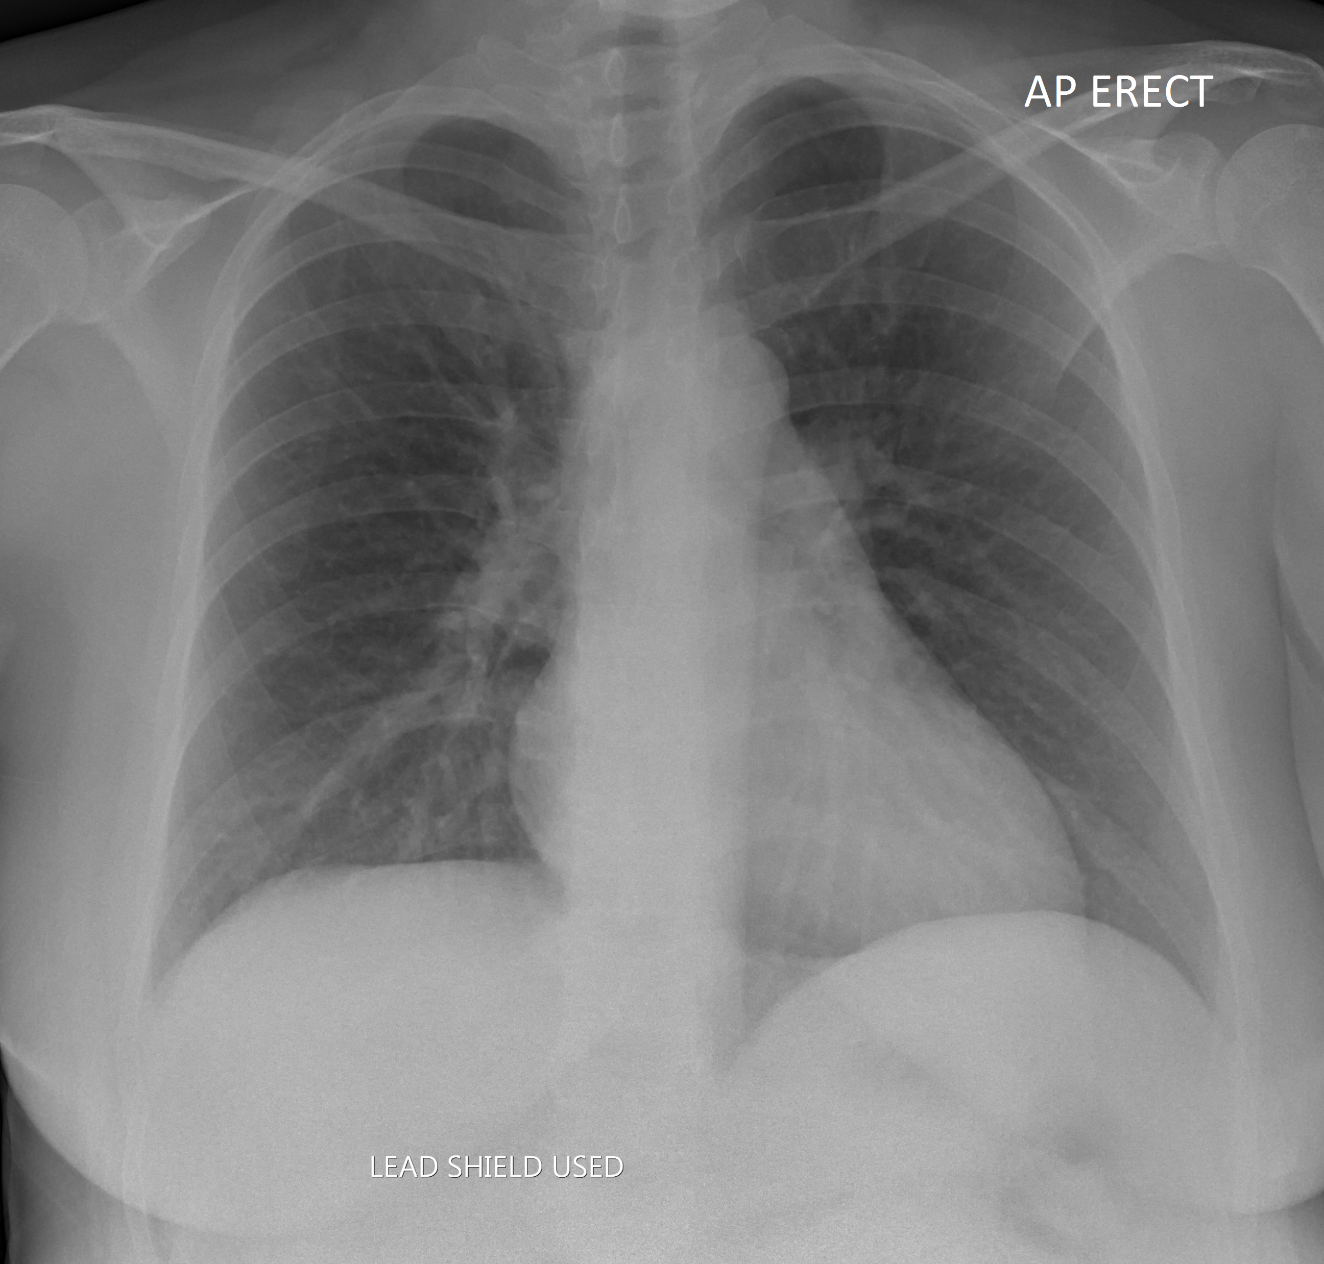
Case courtesy of Henry Knipe, Radiopaedia.org. From the case rID: 36714

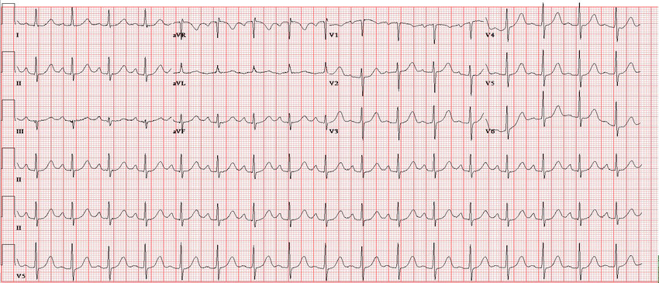

Patel, Nirav & Negi, Smita & Anand, Aashish & Rao, Anantha. (2016). The New Zealand medical journal. 129. 80-83.

Appendix C: Facilitator Cheat Sheet & Debriefing Tips

Include key errors to watch for and common challenges with the case. List issues expected to be part of the debriefing discussion. Supplemental information regarding any relevant pathophysiology, guidelines, or management information that may be reviewed during debriefing should be provided for facilitators to have as a reference.

CXR interpretation: Prominence to the vascular markings (normal in pregnancy). Normal cardiomediastinal contour. Lungs and pleural spaces are clear.

ECG interpretation: Sinus tachycardia at 103 bpm

PE is a reasonable consideration in the DDx. YEARS algorithm in pregnant patient can rule out PE in this patient with no hemoptysis, no signs/sx of DVT and a reasonable alternative diagnosis.

Objectives:
- Recognize physiologic changes in pregnancy (e.g. normal PCO2 in pregnancy is 32mmHg)
- Initiate FHR monitoring during medical emergency in pregnancy
- Demonstrate stepwise pharmacological/respiratory support and treatments for severe asthma exacerbation in pregnancy
- Stepwise pharmacological/respiratory support treatments for severe asthma exacerbation in pregnancy: 1 – Bronchodilators 2 – Ipatropium 3 – systemic corticosteroids 4 – Adjunct therapies (Magnesium sulfate, terbutaline)
- Avoid epinephrine due to concern for uterine vasoconstriction

References

1. Rosen's emergency medicine : concepts and clinical practice. Chapter 174: Medical Emergencies During Pregnancy ( 2022). St. Louis :Mosby,
2. Awad, N. Fleetham, J. Asthma in Pregnancy. Journal of Obstetrics and Gynecology Canada. Volume 17, Issue 1, p27-31, January 1995.
3. Schatz, W., & Weinberger, S. (2022). Management of asthma in pregnancy. In Dieffenbach (Ed.), UpToDate.

